Auction Management System
TA: Akram Tarek
Team ID: 71
Team Members:
- كارين بهاء سمير حزقيال 2023170435 Level 2 Main stream

- فيروز وليد فريد محمود 2023170433 Level 2 Main stream
- ماريو كرم ثابت سعد 2021170660 Level 2 Main stream

- جينيفر هاني محفوظ اثناسيوس 2023170180 Level 2 Main stream
- ماريا رامي رشاد غالي 2023170463 Level 2 Main stream
- كارين اشرف نجيب حبشي 2023170434 Level 2 Main stream
- سهيله وحيد سيد احمد سيد احمد 2023170759 Level 2 Main stream

SQL script
create table Buyer
(
Buyer_ID NUMBER(10),
First_Name varchar2(25),
Last_Name varchar2(25),
constraint Buyer_ID_PK primary key (Buyer_ID)
);

create table Auctioner
(
Auctioner_ID number(10),
First_Name varchar2(25),
Last_Name varchar2(25),
constraint Auctioner_ID_PK primary key (Auctioner_ID)
);

create table Bid
(
Amount number(10),
Buyer_ID number(10),
CONSTRAINT Amount_pk primary key (Amount),
CONSTRAINT Buyer_ID_FK foreign key (Buyer_ID) references Buyer(Buyer_ID)
);

create table Auction
(
Auction_ID number(10) ,
Title varchar2(25),
A_category varchar2(25) ,
Highest_bid number(10),
Start_price number(10),
Auctioner_ID number(10) NOT NULL UNIQUE ,
Bid_amount number(10),
Buyer_ID number(10) NOT NULL UNIQUE ,
CONSTRAINT Auction_ID_pk primary key (Auction_ID),
CONSTRAINT Buyer_ID_FK2 foreign key (Buyer_ID) references Buyer(Buyer_ID),
CONSTRAINT Auctioner_ID_FK2 foreign key (Auctioner_ID) references Auctioner(Auctioner_ID),
CONSTRAINT Bid_Amount_FK foreign key (Bid_amount) references Bid(Amount)
);

create table Seller
(
Seller_ID NUMBER(10),
First_Name varchar2(25),
Last_Name varchar2(25),
constraint Seller_ID_PK primary key (Seller_ID)
);

create table Item
(
Item_ID number(10),
I_Name varchar2(25),
Buyer_ID number(10),
Auction_ID number(10),
Seller_ID number(10),
CONSTRAINT Item_ID_pk primary key (Item_ID),
CONSTRAINT Buyer_ID_FK3 foreign key (Buyer_ID) references Buyer(Buyer_ID),
CONSTRAINT Auction_ID_FK foreign key (Auction_ID) references Auction(Auction_ID),
CONSTRAINT Seller_ID_FK foreign key (Seller_ID) references Seller(Seller_ID)
);

create table Payment
(
Payment_ID number(10),
Buyer_ID number(10),
P_date date,
Method_Name varchar2(25),
Final_Price number(10),
CONSTRAINT Payment_ID_pk primary key (Payment_ID),
CONSTRAINT Buyer_ID_FK4 foreign key (Buyer_ID) references Buyer(Buyer_ID)
);

create table Participate
(
Buyer_ID number(10),
Auction_ID number(10) ,
CONSTRAINT Auction_ID_FK2 foreign key (Auction_ID) references Auction(Auction_ID),
CONSTRAINT Buyer_ID_FK5 foreign key (Buyer_ID) references Buyer(Buyer_ID)
);

create table Preferred_Category
(
Buyer_ID number(10),
P_Category varchar2(25) ,
CONSTRAINT P_Category_pk primary key (P_Category),
CONSTRAINT Buyer_ID_FK6 foreign key (Buyer_ID) references Buyer(Buyer_ID)
);

create table Recieve
(
Buyer_ID number(10),
Bid_Amount Number(25) ,
Auction_ID number(10) ,
CONSTRAINT Auction_ID_FK3 foreign key (Auction_ID) references Auction(Auction_ID),
CONSTRAINT Bid_Amount_fk2 foreign key (Bid_Amount) references Bid(Amount),
CONSTRAINT Buyer_ID_FK7 foreign key (Buyer_ID) references Buyer(Buyer_ID)
);

INSERT INTO Buyer (Buyer_id, First_Name, Last_Name)
VALUES (201, 'John', 'Doe');

INSERT INTO Buyer (Buyer_id, First_Name, Last_Name)
VALUES (202, 'Jane', 'Smith');

INSERT INTO Buyer (Buyer_id, First_Name, Last_Name)
VALUES (203, 'Alice', 'Johnson');

INSERT INTO Seller (Seller_id, First_Name, Last_Name)
VALUES (301, 'Mark', 'Lee');

INSERT INTO Seller (Seller_id, First_Name, Last_Name)
VALUES (302, 'Sarah', 'Brown');

INSERT INTO Seller (Seller_id, First_Name, Last_Name)
VALUES (303, 'Paul', 'Green');

INSERT INTO Auctioner (Auctioner_id, First_Name, Last_Name)
VALUES (101, 'William', 'Black');

INSERT INTO Auctioner (Auctioner_id, First_Name, Last_Name)
VALUES (102, 'Emily', 'White');

INSERT INTO Auctioner (Auctioner_id, First_Name, Last_Name)
VALUES (103, 'Oliver', 'Gray');

INSERT INTO Bid (Amount, Buyer_id)
VALUES (500, 201);

INSERT INTO Bid (Amount, Buyer_id)
VALUES (20000, 202);

INSERT INTO Bid (Amount, Buyer_id)
VALUES (800, 203);

INSERT INTO Payment (Payment_id, Buyer_id, p_Date, Method_Name, Final_Price)
VALUES (501, 201, '10/jan/2023', 'Credit Card', 500);

INSERT INTO Payment (Payment_id, Buyer_id, p_Date, Method_Name, Final_Price)
VALUES (502, 202, '15/feb/2023', 'PayPal', 20000);

INSERT INTO Payment (Payment_id, Buyer_id, p_Date, Method_Name, Final_Price)
VALUES (503, 203, '20/jun/2023', 'Bank Transfer', 800);

INSERT INTO Auction (Auction_id, Title, a_Category, Highest_bid, Start_Price, Auctioner_id, Bid_Amount, Buyer_id)
VALUES (1, 'Painting A', 'Art', 500, 200, 101, 500, 201);

INSERT INTO Auction (Auction_id, Title, a_Category, Highest_bid, Start_Price, Auctioner_id, Bid_Amount, Buyer_id)
VALUES (2, 'Vintage Car', 'Vehicles', 20000, 15000, 102, 20000, 202);

INSERT INTO Auction (Auction_id, Title, a_Category, Highest_bid, Start_Price, Auctioner_id, Bid_Amount, Buyer_id)
VALUES (3, 'Sculpture B', 'Collectibles', 800, 500, 103, 800, 203);

INSERT INTO Recieve (Auction_id, Bid_Amount, Buyer_id)
VALUES (1, 500, 201);

INSERT INTO Recieve (Auction_id, Bid_Amount, Buyer_id)
VALUES (2, 20000, 202);

INSERT INTO Recieve (Auction_id, Bid_Amount, Buyer_id)
VALUES (3, 800, 203);

INSERT INTO Bid (Amount, Buyer_id)
VALUES (500, 201);

INSERT INTO Bid (Amount, Buyer_id)
VALUES (20000, 202);

INSERT INTO Bid (Amount, Buyer_id)
VALUES (900, 204);

INSERT INTO Participate (Buyer_id, Auction_id)
VALUES (201, 1);

INSERT INTO Participate (Buyer_id, Auction_id)
VALUES (202, 2);

INSERT INTO Participate (Buyer_id, Auction_id)
VALUES (203, 3);

INSERT INTO Preferred_Category (Buyer_id, P_Category)
VALUES (201, 'Art');

INSERT INTO Preferred_Category (Buyer_id, P_Category)
VALUES (202, 'Vehicles');

INSERT INTO Preferred_Category (Buyer_id, P_Category)
VALUES (203, 'Collectibles');

INSERT INTO Item (Item_id, I_Name, Buyer_id, Auction_id, Seller_id)
VALUES (401, 'Painting A', 201, 1, 301);

INSERT INTO Item (Item_id, I_Name, Buyer_id, Auction_id, Seller_id)
VALUES (402, 'Vintage Car', 202, 2, 302);

INSERT INTO Item (Item_id, I_Name, Buyer_id, Auction_id, Seller_id)
VALUES (403, 'Sculpture B', 203, 3, 303);

UPDATE Auction
SET a_category = 'Collectibles'
where auction_id =1;

UPDATE payment
SET method_name = 'Cash'
where payment_id =502;

UPDATE payment
SET method_name = 'Cash'
where payment_id =503;

Project screenshots
1st Canvas (Auction Table):
We used combo box (Auction Title), check box (Auction Category), calculated fields (summary) that calculates the maximum highest bid in the auctions, trigger (Next Record button), Alert (Save button), Master Detail (Relation 1 to many between Item and Auction) .

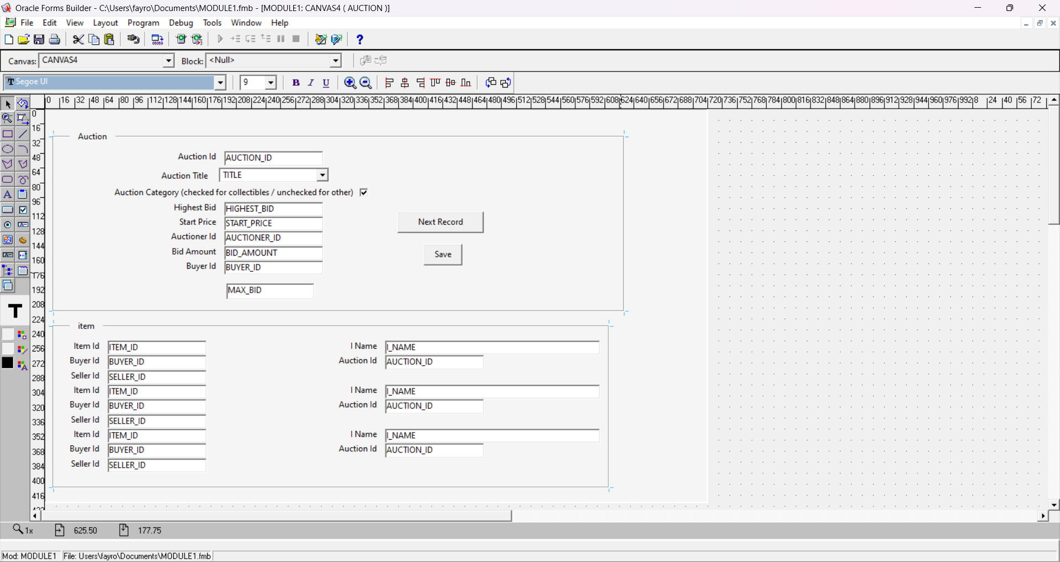

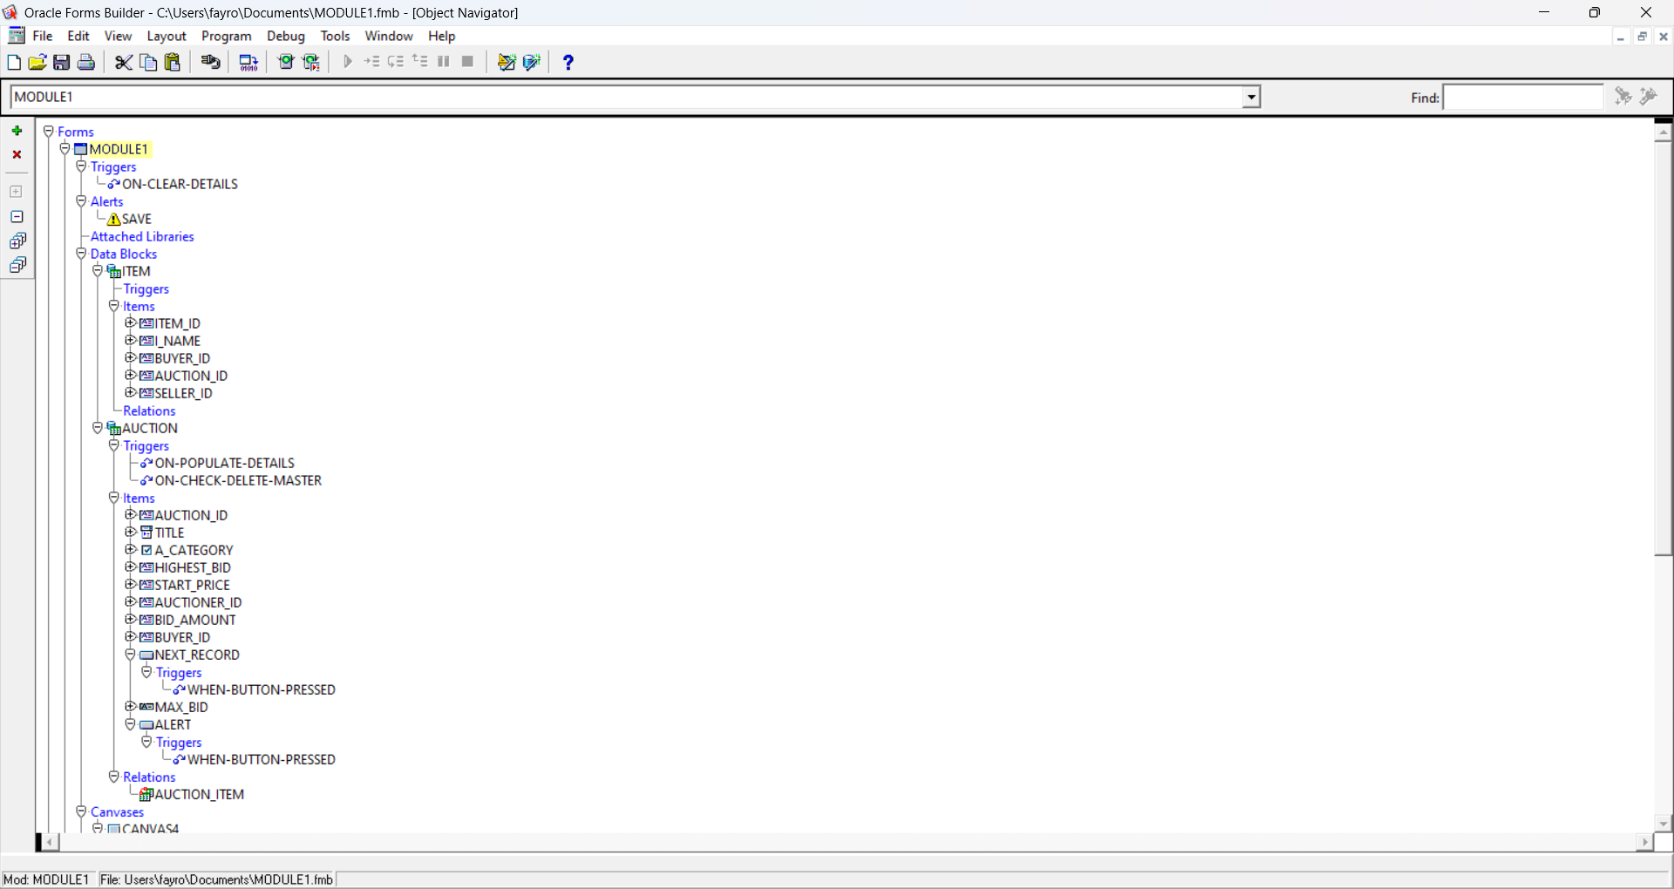

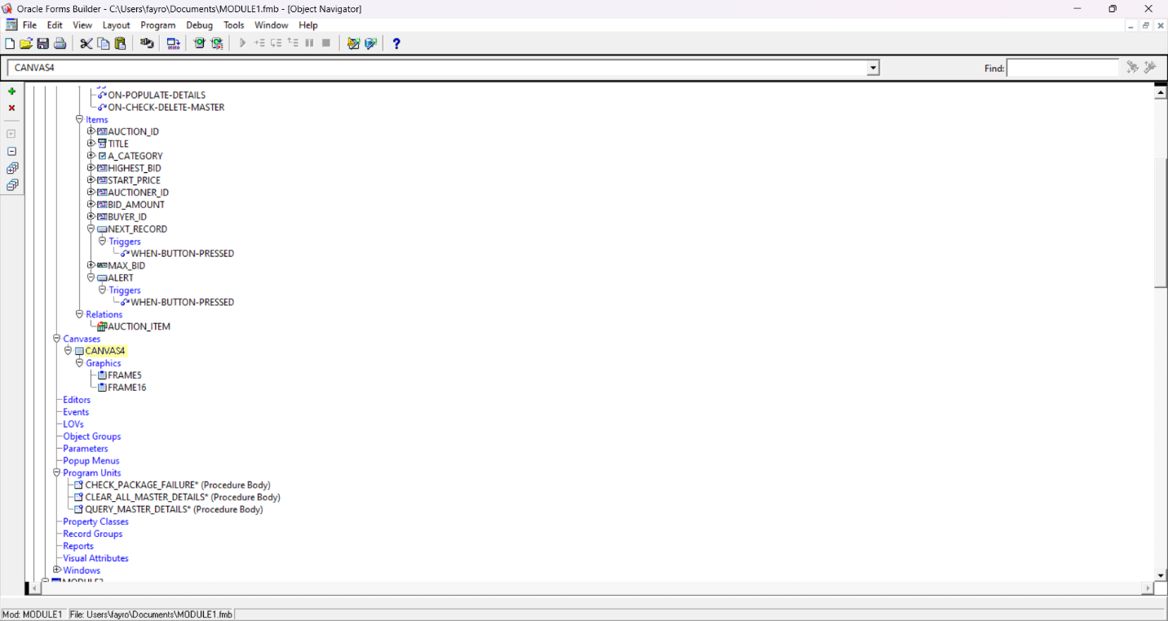
Updates done in properties:
- Combo Box (Auction Title)
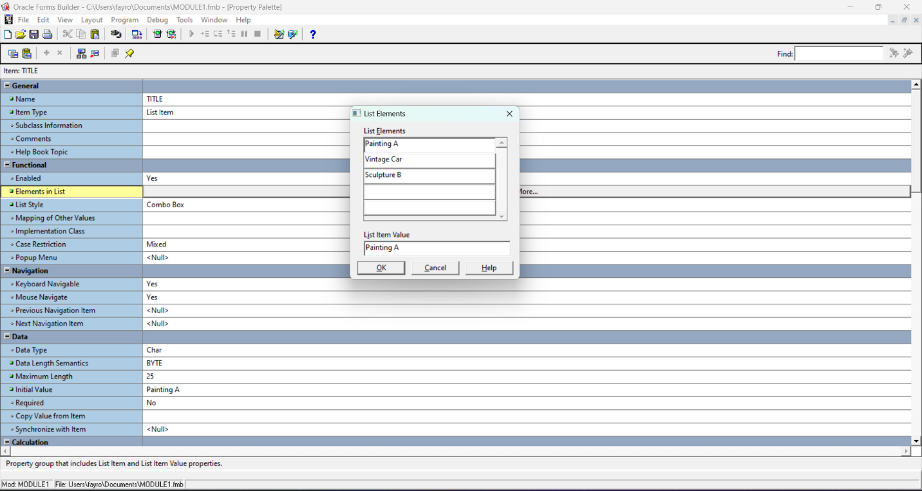

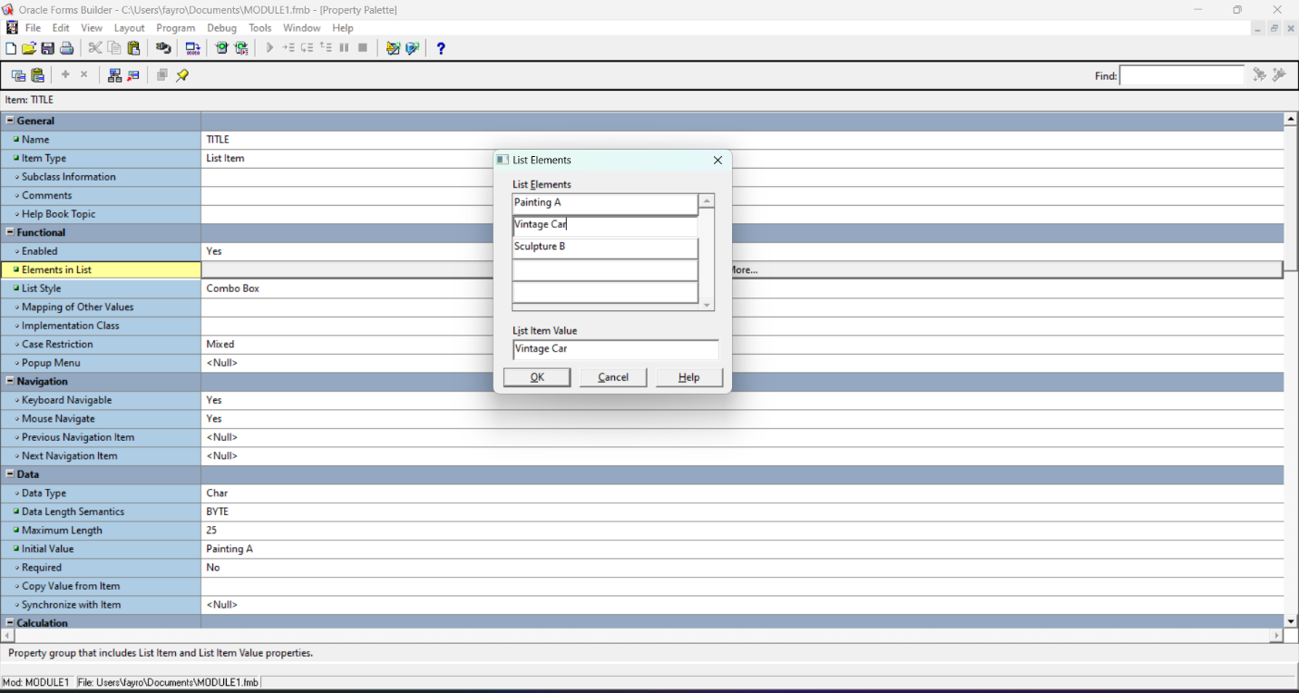

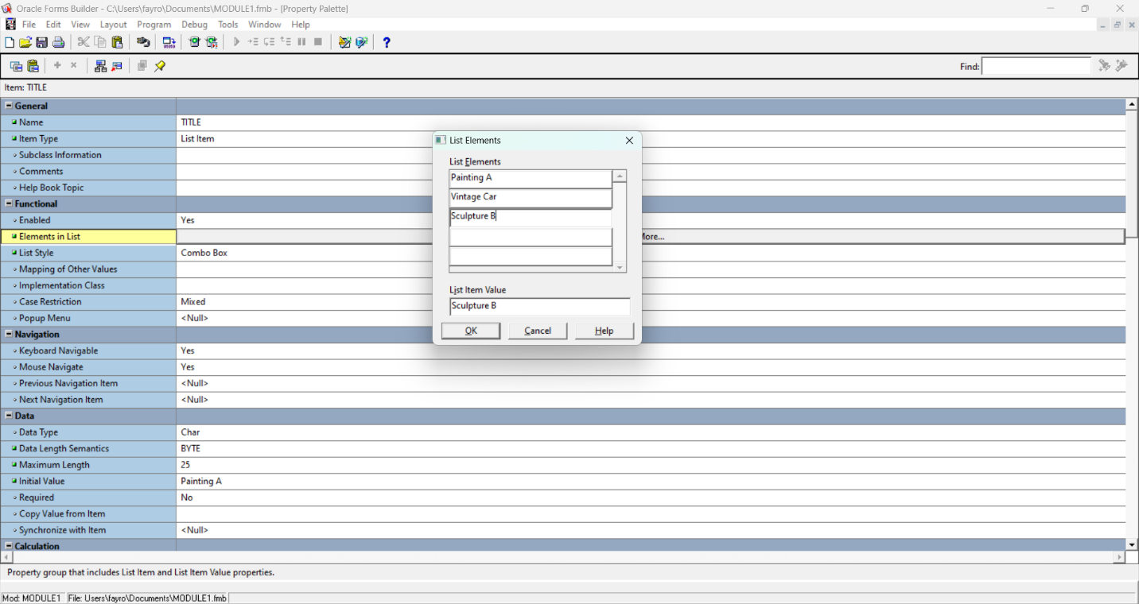

- Check Box (Auction Category)
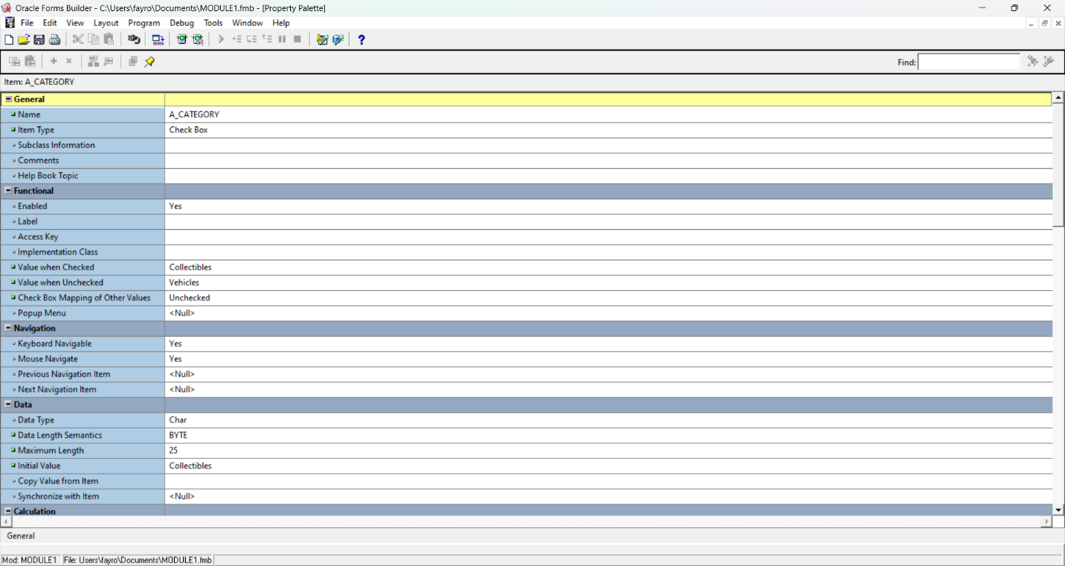

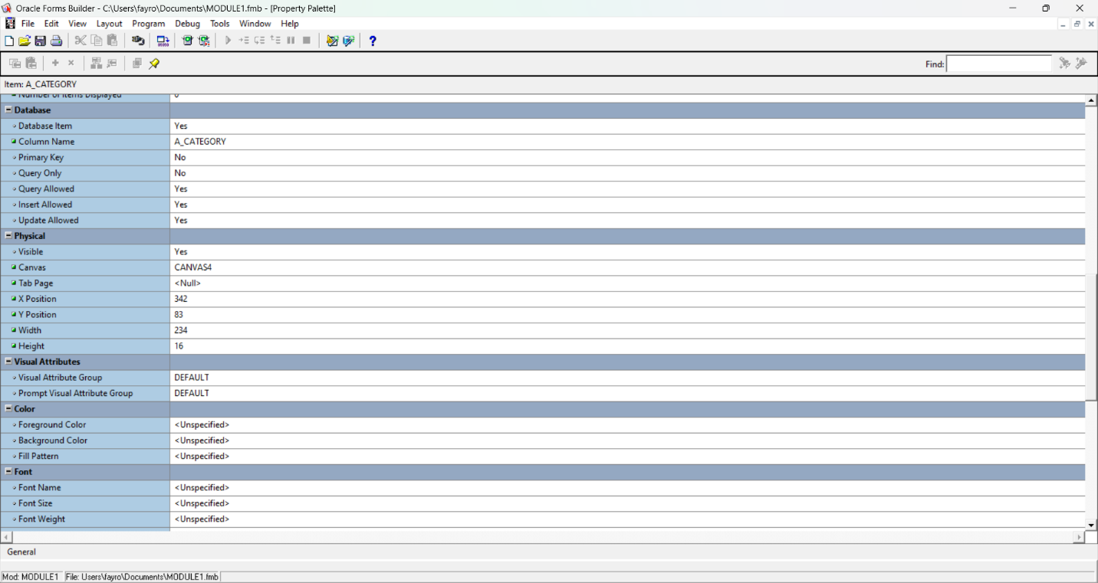

- calculated fields (summary) (Max Highest Bid):
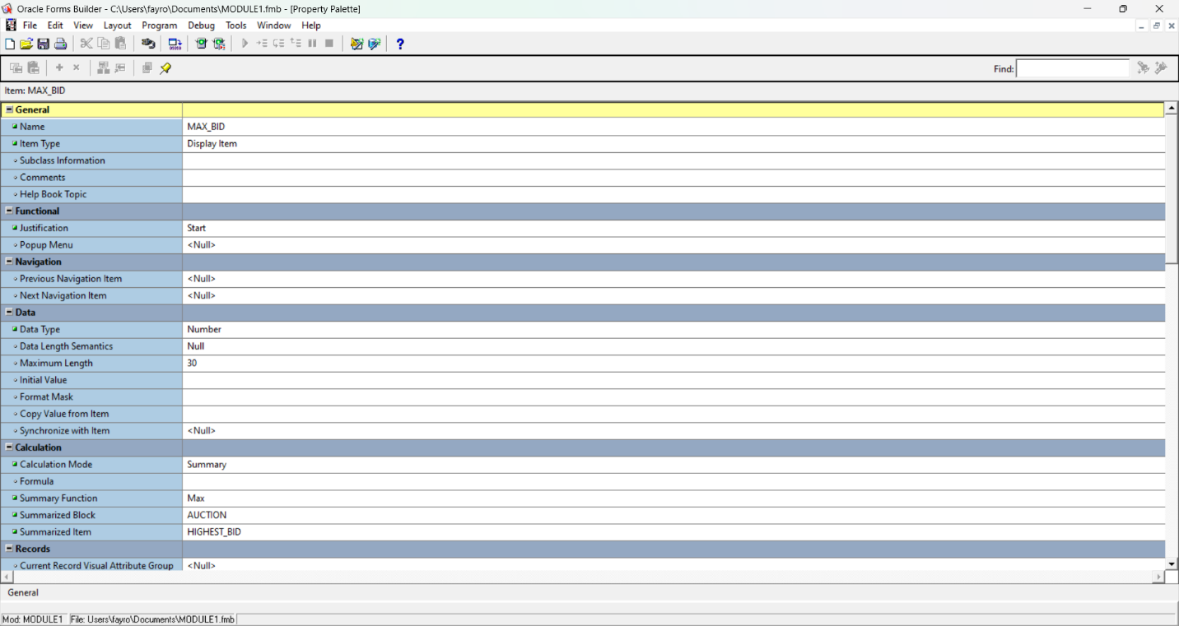

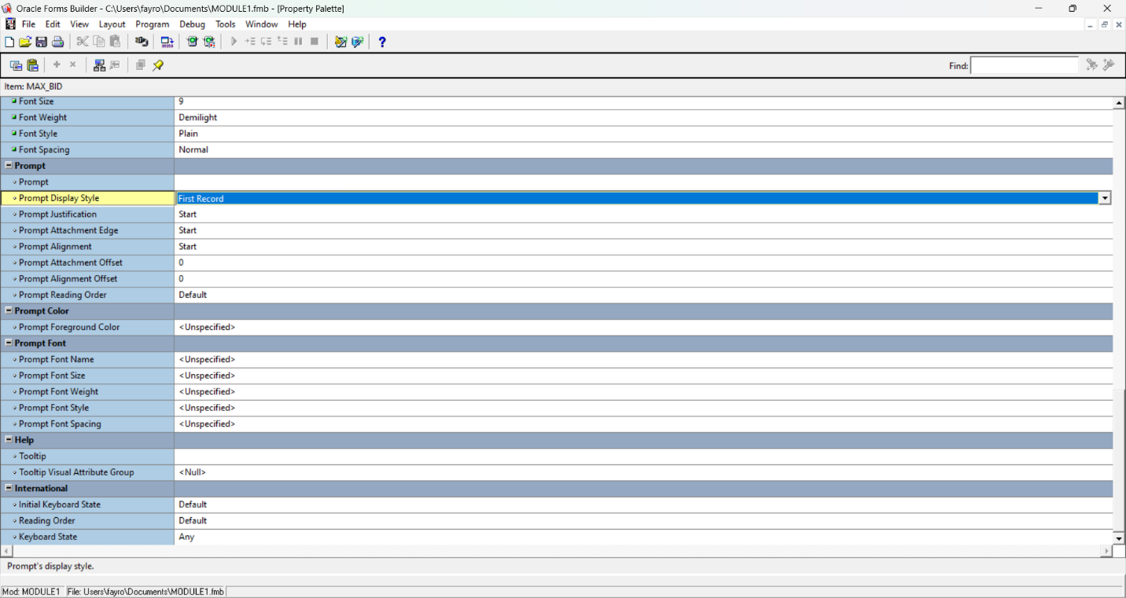

- trigger (Next Record button):
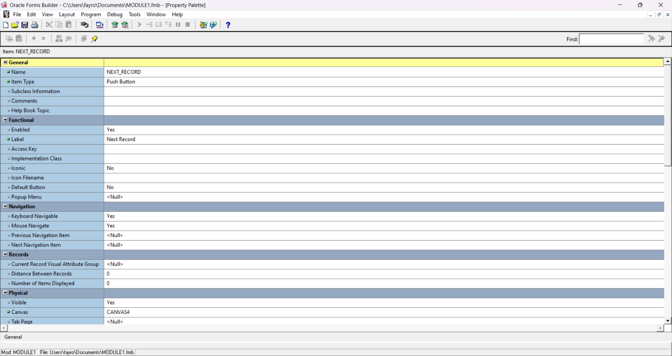

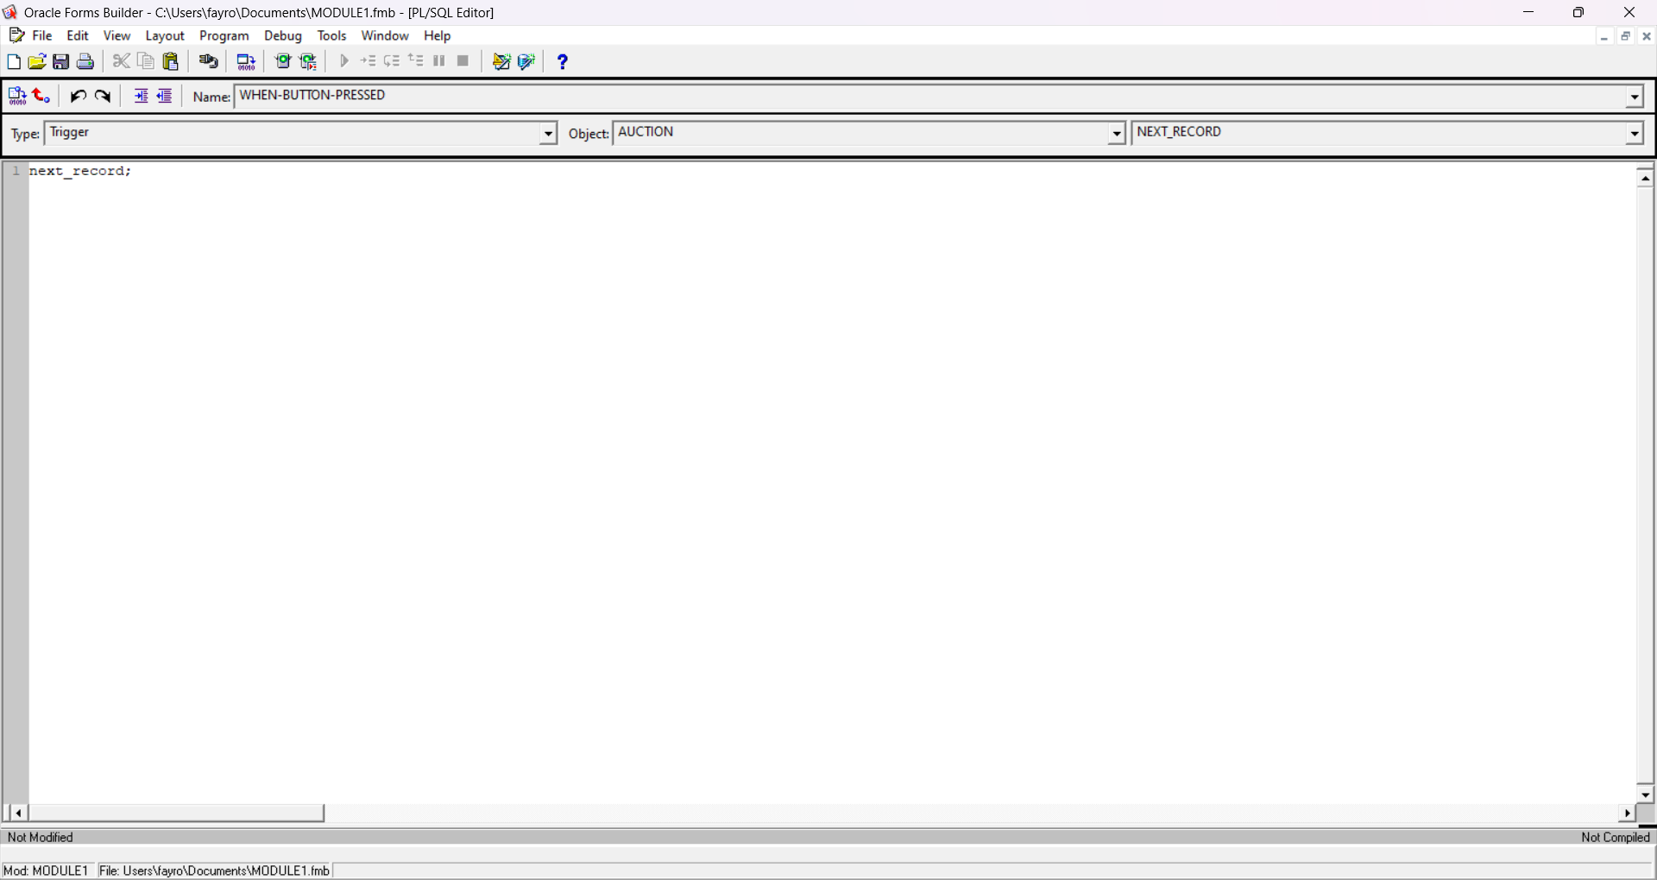

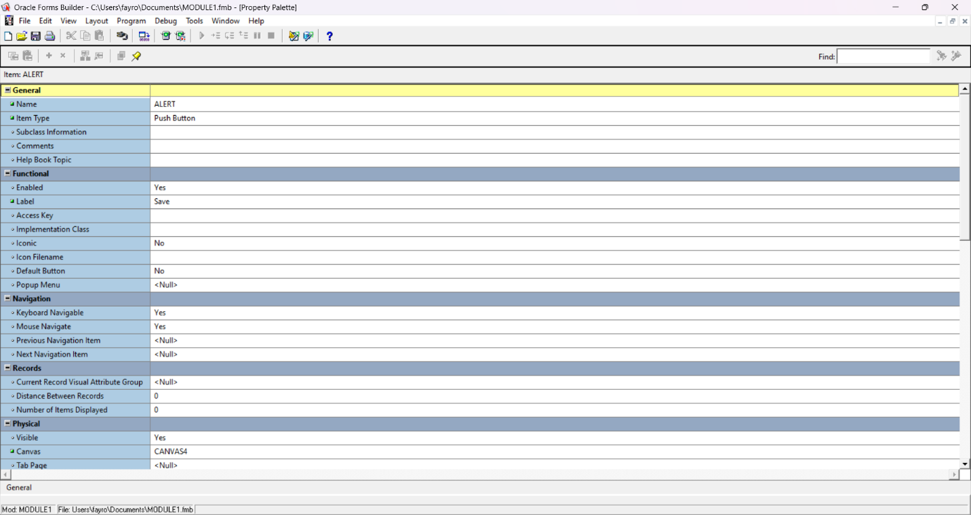
- Alert (Save button):

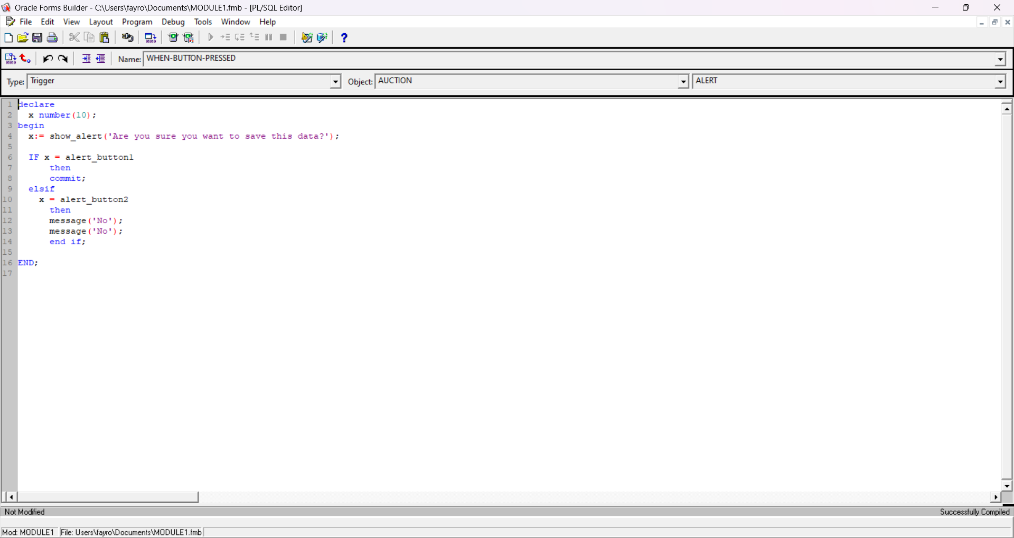

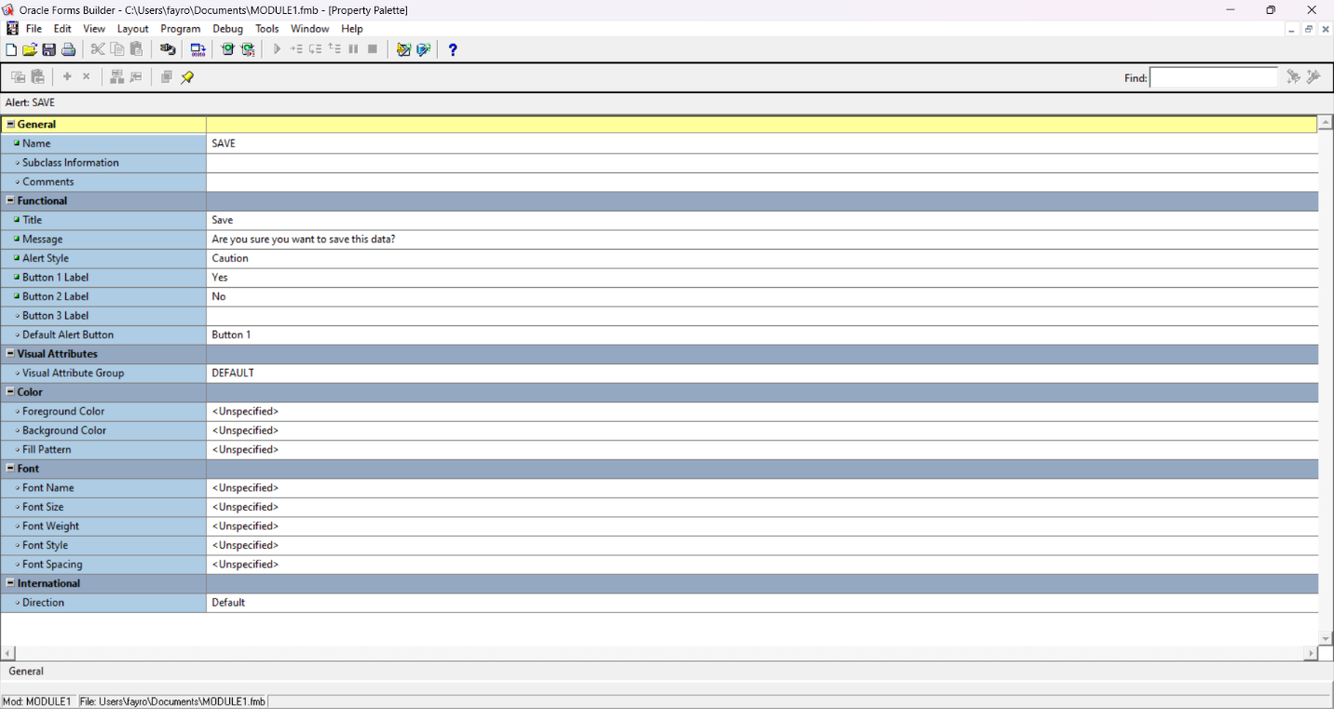

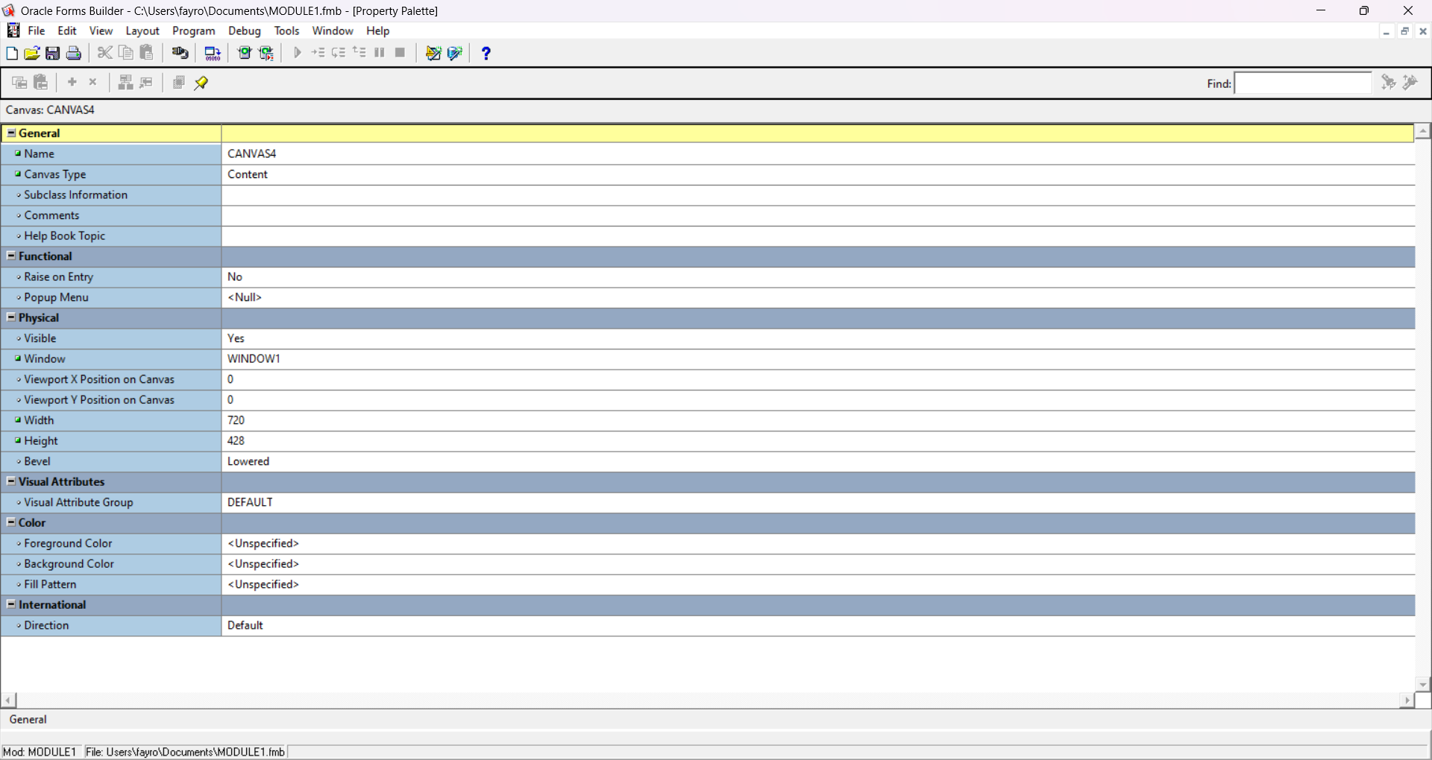
- Master Detail (Relation between Item and Auction):

2nd Canvas (Payment Table):

